FS- Workshop in cooperation with IRPA: Radiation Protection Culture in Waste Management
31 Aug to 2 Sept 2015 Schloss Böttstein, Switzerland

Dear colleagues,

The Association of Radiation Protection of Germany and Switzerland (FS) is organising a workshop in the frame of the IRPA activities for radiation protection culture. The title of the workshop is “Radiation Protection Culture in Waste Management”.

The FS has experience in this subject and has organised different national and international events connected with radiation protection culture and waste management in the last 12 months:
- Forth European Congress “Radiation Protection Culture - A Global challenge, FS and IRPA , June 2014, Geneva, Switzerland
- FS-Symposium “Interim storage, permanent storage, final disposal: Where do we keep our radioactive waste”, September 2014, Mainz, Germany
- “AKE-Seminar “Exemption and Release in Switzerland”, March 2015, PSI, Switzerland
In waste management and in the field of disposal facilities, even NGOs and representatives of citizens´ groups accepted the FS-Symposium and FS-Seminar as a neutral and independent forum.
The FS is inviting all European IRPA societies espec. members of the Nordic Societies, the Belgium Society and the Croatian Society to this workshop. The number of participants for this workshop is limited to 30 persons.

Scope:
Radioactive waste is an unavoidable by-product of the use of radioactive material and nuclear technology. Most radioactive waste comes from nuclear electricity production and the dismantling of nuclear power plants. However, it is also generated in industry from material analysis, in hospitals from medical applications and in universities and research centres for natural sciences and engineering.

Radioactive waste management includes also clearance and exemption as measure to minimise radioactive waste. It influences the economy as well as the exposure of the public.
Main topics are

- Optimisation in radioactive waste management: Dose reduction vs. waste minimisation
- Disposal asap vs. long term interim storage
- Benefits and barriers by a graded approach for disposal of radioactive waste

Working groups will be established to discuss the subjects. First discussion points are already developed and attached to this letter. The participants are kindly requested to read the list of discussion points carefully (see below).

Please give us a short notice, in which group you like to take part (first and second choice) by e-mail to J. Feinhals (ake@fs-ev.org).
The results of the working groups will be summarised in a report.

Venue:
The workshop is scheduled for the 31st of August until the 2nd of September 2015 at the AXPORAMA in Böttstein, Canton Aargau, Switzerland.

Böttstein is located close to the German border (Waldshut-Tiengen), and about 40 km away from airport Zurich-Kloten.

Accommodation:
Rooms are reserved in Böttstein, Switzerland, and Waldshut-Tiengen, Germany:

Schloss Böttstein, Schlossweg 20  CH-5315 Böttstein  Switzerland  Phone +41 (0) 56 269 16 16,  Fax +41 (0) 56 269 16 66  E-mail: info@schlossboettstein.ch  http://www.schlossboettstein.ch/  Price 110 CHF including breakfast. | Hotel Restaurant Waldshuter Hof  Kaiserstr. 56  79761 Waldshut-Tiengen  Telefon +49 (0) 77 51 / 20 08 und 87 51 – 0  Telefax +49 (0) 77 51 / 87 51 - 70  E-Mail: hotel@waldshuter-hof.de  http://www.waldshuter-hof.de/  Price 70 € including breakfast  Keyword: IRPA 2015  reservation ends at 16 Aug. 2015

Registration:
To registrate use the following link:
https://www.bz-psi.ch/school/edit_course_user.php?id=1405&1

For other questions please refer to J. Feinhals (ake@fs-ev.org).

We need your full name and your contact data like address, phone and email until 20 July 2015. There is no fee for the workshop. As there is only a limited number of participants, we kindly ask you to register as soon as possible.

We hope to see you at the workshop in Böttstein.

Best regards

G. Hampel | J. Feinhals
President of Association of Radiation Protection of Germany and Switzerland | Secretary of the Working Group Disposal of Radioactive Waste

Location:

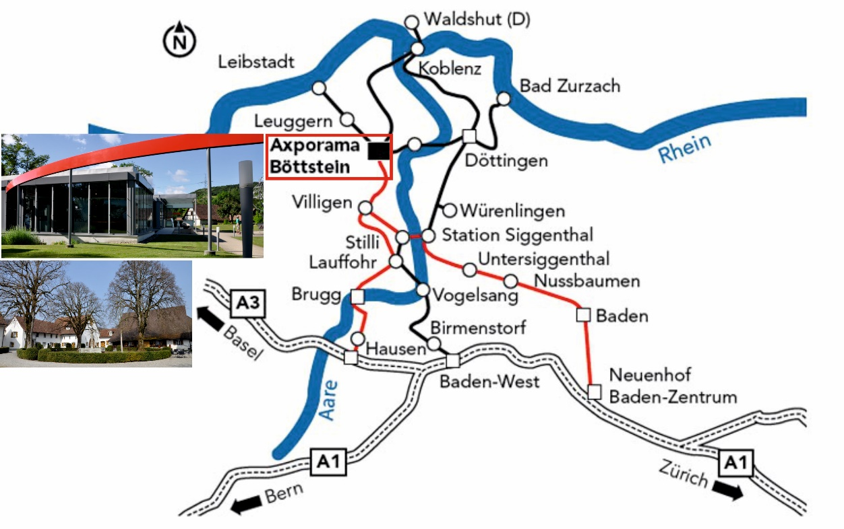

Public transport: http://fahrplan.sbb.ch/bin/query.exe/de

FS- Workshop in cooperation with IRPA:
Radiation Protection Culture in Waste Management
31 Aug to 2 Sept 2015 Schloss Böttstein, Switzerland

Points of Discussion / Working Groups

This is a list of possible issues for different working groups during the FS-Workshop “Radiation Protection Culture in Waste Management”. Please read this list carefully and decide, in which working group you like to take part. Please send us your choice of two working groups together with your registration:

1 | Dose reduction vs. waste minimisation:  Many countries have a law about waste minimisation in force. This underruns the imperative of dose reduction, as waste minimisation causes further work in controlled areas. A holistic optimisation process might be the right solution to get out of this dilemma, considering both the dose reduction and the waste minimisation. In some cases a modification of the national law is necessary. Switzerland has explicit regulations for waste minimisation, as Germany is still trusting in the market.  References: Radioactive Waste Management Programmes in OECD/NEA Member Countries, 2015 (e.g.: https://www.oecd-nea.org/rwm/profiles/Sweden_profile_web.pdf,  https://www.oecd-nea.org/rwm/profiles/Spain_profile_web.pdf)
2 | Disposal of small amounts of waste:  Countries, which are in good progress to plan a national geological disposal facility, shall take over a lighthouse function for other countries, which are still in the starting phase. There are many countries in the world producing only a small amount of radioactive waste every year. But concepts for disposal facilities in lighthouse countries are dedicated for large amounts of radioactive waste and may not be applicable for small amounts. Do we need a new concept for countries with small amounts of radioactive waste?  References: IAEA SSG-1 Borehole Disposal Facilities for Radioactive Waste, 2009
3 | Interim storage vs. disposal:  The commissioning of a disposal facility is often postponed due to many different reasons. Due to these delays the duration of the interim storage last much longer than planned. Often additional work has to be done to keep the interim storage safe causing additional dose for the workers. Do we need a speed up of the process for a disposal facility?  References: ICRP 81, Radiological Protection in Geological Disposal of Long-Lived Solid Radioactive Waste; ICRP 103, The 2007 Recommendations of the International Commission on Radiological Protection
4 | How to deal with safety culture deficiencies?  Safety culture is not a constant standard existing in the same way at the beginning of nuclear technology as today. How to deal with legacies with radioactive waste, which we classify today as legacy but in former times they were in compliance with state of the art? How can we avoid a general demonization of the waste management of nuclear waste today by the legacies of waste from yesterday?  Reference: F. Börchers, H.W. Engelmann, J. Feinhals, H. Schulze, The Proper Radiation Protection Balance, IRPA-EU-14, Geneva 2014
5 | Capacity abundance vs. waste minimisation:  The capacity of a disposal facility is not a short resource in every country. Some countries have a concept of low cost for disposal to reduce the risk of illegal disposal of radioactive waste. Which concept is recommendable: capacity in a disposal facility in abundance or a short capacity to stimulate waste minimisation?
6 | Graded approach for disposal concepts:  Some countries like Germany and Switzerland pursue a concept with a disposal only in geological facilities. Other countries like France and Spain are using a graded approach with an additional near surface disposal for low and intermediate level waste with short half life. Are both concepts equivalent or has one concept to be preferred from the aspect of safety culture?  References: M. Dützer, Andra: 45 years of operation of near surface repositories; FS-Symposium 2014
7 | A common dose concept for clearance and release?  The clearance system is very important for a national waste management programme. Clearance is one of the most important tools to ensure that radioactive waste generated is kept to a minimum practicable. A dose concept of up to 300 µSv/yr for release of a site (IAEA: WS-G-5.1) should fit to the other dose concept of some 10 µSv/yr for clearance of materials and exemption (IAEA: RS-G-1.7). It should be checked the possibility of a common dose concept for the release/clearance of material and sites from regulatory control as well as for exemption. Actually, the description of two different concepts in two guides has a strong overlap for example for materials resulting from the release of a site on the one hand and clearance of parts of buildings or excavated soil on the other hand. It should be checked, if the existing two concepts should be merged together in one concept.  References: IAEA: RS-G-1.7: Application of the Concepts of Exclusion, Exemption and Clearance, 2004; WS-G-5.1: Release of Sites from Regulatory Control on Termination of Practices, 2006

Please give us a short notice in which group you like to take part (first and second choice) by e-mail to J. Feinhals (ake@fs-ev.org).

 | Working group | 1st choice | 2nd choice
1 | Dose reduction vs. waste minimisation
2 | Disposal of small amounts of waste
3 | Interim storage vs. disposal
4 | How to deal with safety culture deficiencies?
5 | Capacity abundance vs. waste minimisation
6 | Graded approach for disposal concepts
7 | A common dose concept for clearance and release?

Your name:

